John Carroll
Jcc0044/902521946
Computer Architecture
Homework 3
Theme: Buses
All questions are of equal weight. Show your work to receive credit.

- List and briefly define two approaches of dealing with multiple interrupts.
Answer:
A disabled interrupt simply means that the processor can and will ignore that interrupt request signal.
Creating priorities for interrupts and to allow an interrupt of higher priority to cause a lower-priority interrupt handler to be it, interrupted.
- a. What are the benefits of using a hierarchy of buses over a single bus?
Answer:
Reduce propagation delays; allow more drivers to be spread across buses; allow each bus to have its own speed.
b. Discuss methods of bus arbitration.
Answer:
-Centralized (commonly used)
-Distributed (rarely used - only instance I know is DEC)
Advantage of distributed bus arbiter: no single point of failure
-Daisy-chained (cheap - requires no special hardware)

- Consider a hypothetical 32-bit microprocessor having 32-bit instructions composed of two fields: the first 9-bits contains the op-code and the remainder the immediate operand or an operand address.
a. What is the maximum directly addressable memory capacity (in bytes)?
Answer: 2⁽³²⁻⁸⁾ = 2²⁴ = 16,777,216 bytes = 16 MB

- Discuss the impact on the system speed if the microprocessor has:
(i) a 32-bit local address bus and a 16-bit local data bus, or
Answer: Instruction and data transfers would take three bus cycles each, one for the address and two for the data. Since If the address bus is 32 bits, the whole address can be transferred to memory at once and decoded there; however, since the data bus is only 16 bits, it will require 2 bus cycles (accesses to memory) to fetch the 32-bit instruction or operand.

(ii) a 16-bit local address bus and a 16-bit local data bus.
Answer: Instruction and data transfers would take four bus cycles each, two for the address and two for the data. Therefore, that will have the processor perform two transmissions in order to send to memory the whole 32-bit address; this will require more complex memory interface control to latch the two halves of the address before it performs an access to it. In 3 0 0 5 5 9 4 0 7 0 0 6 0 0 0 2 addition to this two-step address issue, since the data bus is also 16 bits, the microprocessor will need 2 bus cycles to fetch the 32-bit instruction or operand.

c. How many bits are needed for the program counter and the instruction register?
Answer: The PC needs 24 bits (24-bit addresses), and the IR needs 32 bits (32-bit addresses).

- Consider a hypothetical microprocessor generating a 16-bit address (assume that the program counter and the address registers are 16-bit wide) and having a 16-bit data bus.

  - What is the maximum memory address space that the processor can access directly if connected to a “16-bit memory”?
Answer: The maximum memory address space = 2¹⁶ = 64 Kbytes.

  - What is the maximum memory address space that the processor can access directly if connected to an “8-bit memory”?
Answer: The maximum memory address space = 2¹⁶ = 64 Kbytes.

  - What architectural features will allow this microprocessor to access a separate “I/O space”?
Answer: Separate I/O instructions are needed because during its execution will generate separate its own signals I/O signals. That signals will be different from the memory signals, which is generated during the execution for memory instructions. Therefore, one more output pin will be needed to carry I/O signals.

  - If an input and an output instruction can specify an 8-bit I/O port number, how many 8-bit I/O ports can the microprocessor support? How many 16-bit I/O ports?
Answer:
Part1) Can support 2⁸ = 256 8-bit input ports, and 2⁸ = 256 8-bit output ports.
Part2) Can support 2⁸ = 256 16-bit input ports, and 2⁸ = 256 16-bit output ports.

- Consider a microprocessor, with a 32-bit external data bus, driven by a 2 GHz input clock. Assume this microprocessor has a bus cycle whose minimum duration equals four (4) input clock cycles.
What is the maximum data transfer rate that this microprocessor can sustain?
To increase its performance, would it be better to make its external data bus 64-bits or to double the external clock frequency supplied to the microprocessor? State any other assumptions you make, and explain. Hint: Determine the number of bytes that can be transferred per bus cycle.
Answer:
Minimum bus cycle duration = 4 clock cycles and bus clock = 8 MHz
Maximum bus cycle rate = 8 M / 4 = 2 M/s
Data transferred per bus cycle = 16 bit = 2 bytes
Maximum data transfer rate per second = bus cycle rate * data per bus cycle = 2 M * 2 = 4 Mbytes/sec.
To increase performance, it would be better to double the external data bus to 64-bits, making it wider and thus more data can flow at the same speed. If you were to double the clock frequency, the main memory speed would also need to be doubled to keep up with the microprocessor.

- Discuss with a diagram the operation of a synchronous read/write from/to memory.
Answer:
A memory module recognizes the address and, after a delay of one cycle, places the data on the data lines. The processor reads the data from the data lines and drops the read signal. For a write operation, the processor puts the data on the data lines at the start of the second cycle and issues a write command after the data lines have stabilized. The memory module copies the information from the data lines during the third clock cycle.
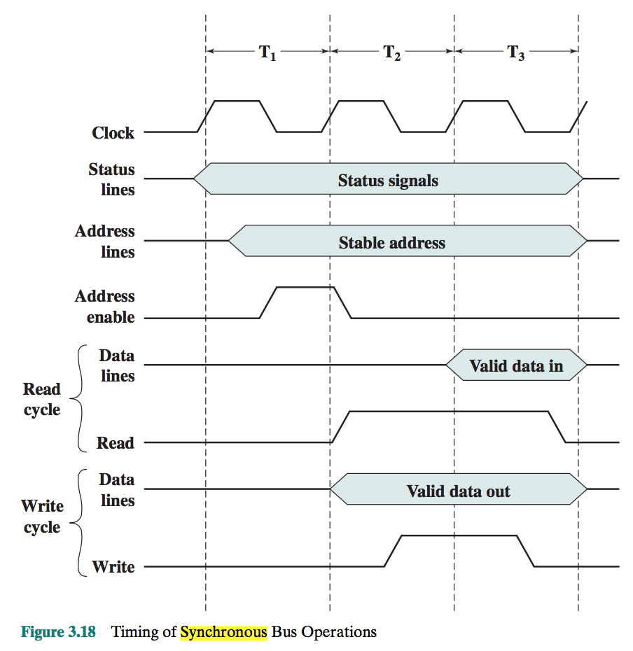

- Discuss the significant characteristics of QPI and its advantages over shared-bus architecture.
Answer:
Multiple direct connections: Multiple components within the system enjoy direct pairwise connections to other components. This eliminates the need for arbitration found in shared transmission systems.
Layered protocol architecture: As found in network environments, such as TCP/IP-based data networks, these processor-level interconnects use a layered protocol architecture, rather than the simple use of control signals found in shared bus arrangements.
Packetized data transfer: Data are not sent as a raw bit stream. Rather, data are sent as a sequence of packets, each of which includes control headers and error control codes.
Advantages: The point-to-point links use fewer signals than the shared bus architecture and provides higher bandwidth, transferring data in both directions simultaneously. The interface also supports multiple memory controllers and efficiently manages the coherence of the processor caches in the system, which is needed for a multiple processor and scalable server systems. The interface provides a robust set of mechanisms to handle errors and recover from them without shutting down the entire system. Intel QPI is defined to meet these needs.
- Higher bus bandwidth due to point-to-point links.
- Efficient memory organization and lower memory access latencies

